Validation

To start of validation of the music player was taken

**Album Validation**

To start I took a normal, corrupted, and non-embedded MP3 file to test the error messages of the album window. The program recognized each of these files and gave out the proper response to these.

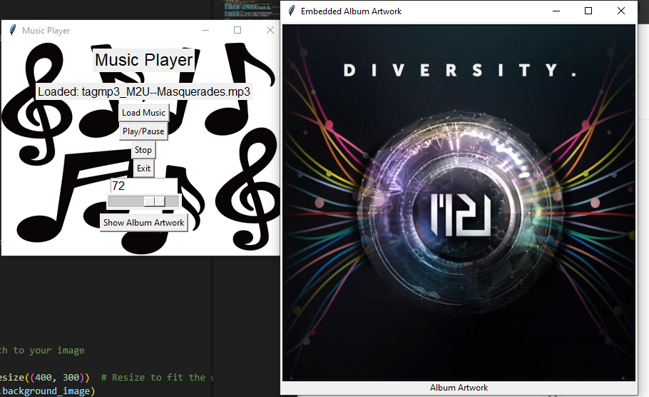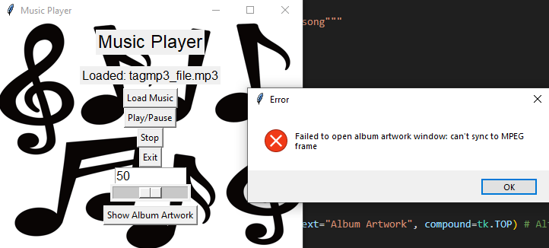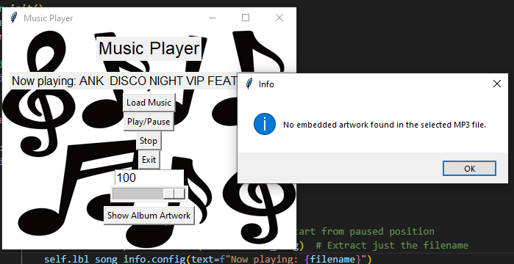

**MP3 Validation**

The program had a functional file as well as a corrupt one running through it. The program at first was unable to tell if the file was corrupted. I realized when I wrote the code I put it to valid the file when played not loaded so all I had to do was move the error message down to the play/pause section for it to function properly. 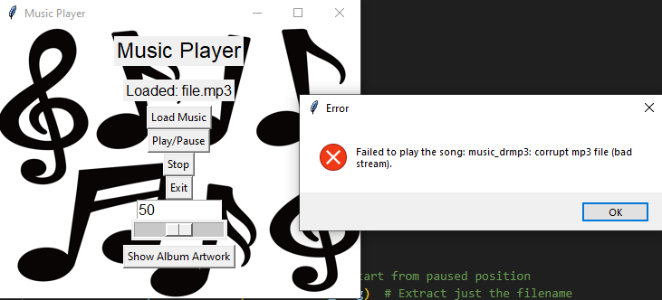

I also tested if the file would let you load new music while the song was playing or prompt you to stop the music first in which it passed.

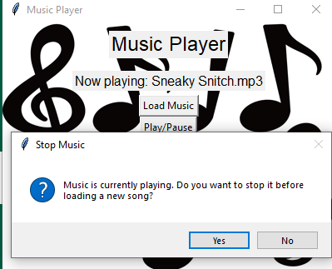

**Volume Validation**

To check if the input box for the volume worked, I input a proper number, a number that was too large, a number too small, and a word. The program could tell the difference and notify the user if the number was merely out of range or if it was not properly formatted.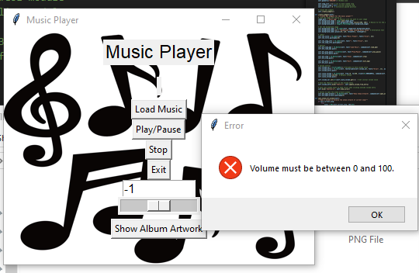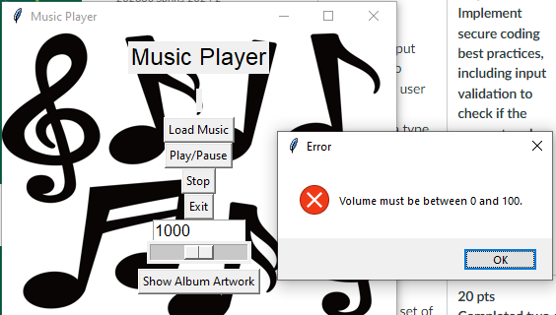

I also checked the slider to see if it worked properly and changed the number accordingly in which it did.

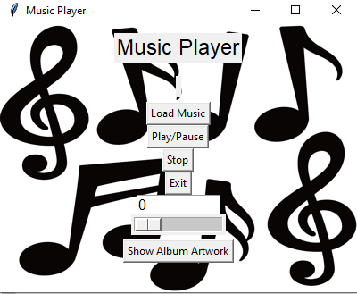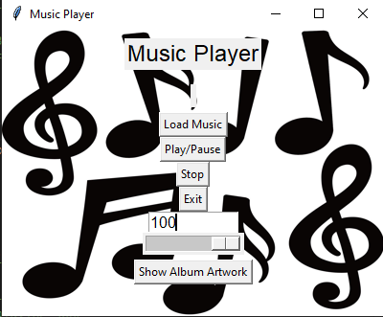

**Stop Button**

I then went to make sure the stop button would unload the song for the user the result was a success.

